BAHRIA UNIVERSITY (KARACHI CAMPUS)

Assignment 3
CLO 3

Discrete Structures.

Class: (BSE 1A/B/C)
Course Instructor: (FAIZ UL HAQUE ZEYA) Max Marks:5
Due date: 6 /6/2023
Student’s Name: ____________________ Reg. No: _________



Q1. Find Google’s Page rank of each page with damping factor 0.85 and three(3) iterations (3.5 marks)

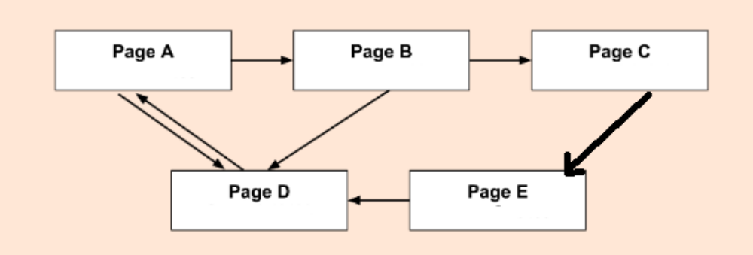

Q2 Find Twitter’s producer-producer cosine similarity of all pairs. (1.5 marks)

